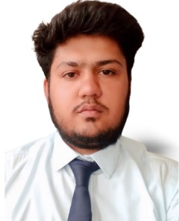**NAME:NAITIK PAREEK**

**Date:13July 2022**

**Email: naitikpareek104@gmail.com**

**Contact No.: +91-7850088961gmail.co**

**Permanent &Correspondence Address: Personal Data:**

**Kalyan Sadan Shiwar Date of Birth – 30 Sep. 2004**

**(322704) Sawai Madhopur Gender – Male**

**Rajasthan Nationality – Indian**

**Objective:**

To obtain challenging positions to initiate a career that will allow me to apply my skills and to accumulate knowledge.

**Personal Snapshot:**

B.Tech from Poornima Institute of Engineering and Technology, Jaipur

(Approval by RTU)

**Academics:**

* 10th (2019) from Bhanu Public Sec School with84.5%
* 12th (2021) from KrishnaVidhya Mandir School with 96%
* Graduation (2025)

**Specialization in B.Tech:**

* C – Programming
* Problem Solving
* HTML

**Core Competence:**

* Self-motivated and efficient in leading a team
* Good with analytical and problem solving techniques
* Capable of handling stressful environment

**Certifications and honors:**

* Certificate of presentation – ICSIS 2022

**Personal Interest:**

* Playing chess
* Seeing Movie
* travelling